Face Recognition Using Deep Neural Networks: From Theory to Implementation

Abstract
Face recognition has become one of the most widely adopted applications of deep learning in computer vision. Modern systems rely on convolutional neural networks (CNNs) to generate compact numerical representations (embeddings) of facial images, which can then be compared for identity verification or recognition. This report outlines the theoretical foundations of neural network–based face recognition, describes the training methodology, and explains how these concepts are implemented in Python using the face_recognition library. Scientific references are provided to situate the work within the broader research landscape.

1. Introduction
Face recognition is a biometric technique that leverages deep neural networks to identify or verify individuals based on facial features. Unlike traditional handcrafted feature approaches, CNN-based models learn hierarchical representations directly from data, enabling robust performance under varying conditions such as lighting, pose, and occlusion.

2. Neural Network Foundations
The core of modern face recognition systems is the Convolutional Neural Network (CNN). CNNs consist of multiple layers that progressively extract features from raw pixel data:
- Convolutional layers capture local patterns such as edges and textures.
- Pooling layers reduce dimensionality while preserving salient information.
- Fully connected layers integrate features into a compact representation.
For face recognition, the CNN is trained not to classify faces directly but to produce a 128-dimensional embedding vector that uniquely represents each face. This embedding acts as a “signature” for comparison.

3. Training Methodology
The training paradigm is based on deep metric learning, specifically the triplet loss function introduced in Google’s FaceNet (Schroff et al., 2015). The objective is to minimize the distance between embeddings of the same identity (anchor and positive) while maximizing the distance from embeddings of different identities (anchor and negative). This ensures that embeddings cluster tightly for the same person and remain well separated across individuals.
Datasets commonly used for training include:
- Labeled Faces in the Wild (LFW) – benchmark dataset for unconstrained face recognition.
- MS-Celeb-1M – large-scale dataset with millions of celebrity images.

4. Implementation in Python
The face_recognition library, built on top of dlib, provides a practical interface for applying pretrained CNN models. The workflow is as follows:
- Encoding known faces
Python
encodes = face_recognition.face_encodings(img)
Each face image is converted into a 128-D embedding.

- Capturing live frames

Python
cap = cv2.VideoCapture(0)
Frames are acquired from a webcam.

- Detecting and encoding faces in frames

Python
face_locations = face_recognition.face_locations(frame)
encodes_frame = face_recognition.face_encodings(frame, face_locations)

- Comparing embeddings

Python
matches = face_recognition.compare_faces(encodeListKnown, encodeface)
faceDis = face_recognition.face_distance(encodeListKnown, encodeface)
The system computes Euclidean distances between embeddings. The smallest distance indicates the closest match.

- Visualization

Bounding boxes and labels are drawn around detected faces using OpenCV.

5. Type of Training
The model used in face_recognition is pretrained. It was trained using supervised deep metric learning on large-scale datasets. Users do not need to retrain the CNN; instead, they only provide reference images for known individuals, and the system compares embeddings at runtime.

6. Scientific References
- Schroff, F., Kalenichenko, D., & Philbin, J. (2015). FaceNet: A Unified Embedding for Face Recognition and Clustering. Proceedings of the IEEE Conference on Computer Vision and Pattern Recognition (CVPR).
- Taigman, Y., Yang, M., Ranzato, M., & Wolf, L. (2014). DeepFace: Closing the Gap to Human-Level Performance in Face Verification. CVPR.
- Amos, B., Ludwiczuk, B., & Satyanarayanan, M. (2016). OpenFace: A general-purpose face recognition library with mobile applications. CMU-CS-16-118.
- King, D. E. (2009). Dlib-ml: A Machine Learning Toolkit. Journal of Machine Learning Research.

7. Conclusion
Face recognition systems based on CNN embeddings represent a significant advancement in biometric technology. By leveraging pretrained models such as those in dlib and face_recognition, researchers and practitioners can implement robust recognition pipelines with minimal effort. The scientific foundation rests on deep metric learning, and the practical implementation in Python demonstrates how theoretical concepts translate into real-world applications.

Evaluation of Face Recognition Systems Using Deep Neural Network Embeddings

Abstract
Face recognition systems based on deep learning have achieved remarkable accuracy in biometric identification. This report presents a practical evaluation pipeline implemented in Python using the face_recognition library. The system encodes facial images into 128-dimensional embeddings via a pretrained convolutional neural network (CNN), compares them against known identities, and evaluates performance using standard classification metrics. The methodology, implementation, and results visualization are described in detail, with references to the scientific foundations of deep metric learning.

1. Introduction
Face recognition is a biometric technique that leverages deep neural networks to identify individuals. Modern systems do not rely on handcrafted features but instead use CNNs to learn embeddings that capture discriminative facial characteristics. Evaluating such systems requires rigorous testing on unseen data and the computation of performance metrics such as accuracy, precision, recall, and F1 score.

2. Neural Network Foundations
The underlying model in the face_recognition library is based on dlib’s deep learning face recognition model, which itself is inspired by FaceNet (Schroff et al., 2015). The CNN transforms each facial image into a 128-dimensional embedding vector. These embeddings are compared using Euclidean distance: smaller distances indicate higher similarity. Training is performed using triplet loss, ensuring embeddings of the same identity cluster together while embeddings of different identities remain far apart.
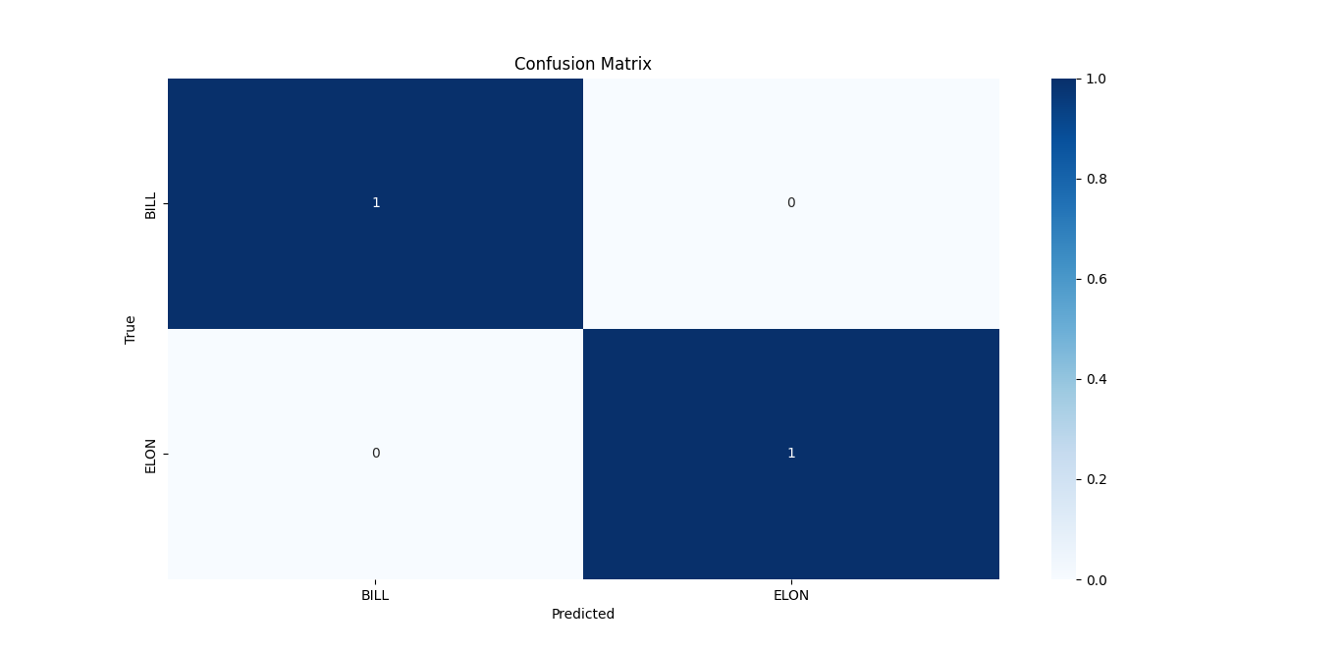

3. Training and Testing Workflow

3.1 Training Phase
- Images of known individuals are stored in the persons directory.
- Each image is encoded into a 128-D embedding using face_recognition.face_encodings.
- The embeddings are stored in encodeListKnown, and the corresponding labels are stored in classNames.

3.2 Testing Phase
- Test images are stored in the Test directory.
- Each test image is processed to extract embeddings.
- The true label is derived from the filename (e.g., Alice_1.png → label = “Alice”).
- The embedding is compared against known embeddings using:
  - compare_faces → Boolean match decision.
  - face_distance → Euclidean distance to all known embeddings.
- The predicted label is assigned based on the closest match or “Unknown” if no match is found.

4. Evaluation Metrics
The system computes:
- Accuracy: proportion of correctly classified faces.
- Precision: proportion of true positives among predicted positives.
- Recall: proportion of true positives among actual positives.
- F1 Score: harmonic mean of precision and recall.
These metrics are calculated using sklearn.metrics functions with macro averaging to account for multiple classes.

5. Confusion Matrix Visualization
A confusion matrix is generated to provide a detailed view of classification performance across all identities. Using seaborn.heatmap, the matrix highlights:
- Correct predictions along the diagonal.
- Misclassifications off-diagonal. This visualization enables identification of specific identities that are more prone to recognition errors.

6. Implementation in Python
The evaluation pipeline is implemented as follows:
- Data loading: images from persons and Test directories.
- Encoding: conversion of images to embeddings.
- Prediction: nearest-neighbor classification using embedding distances.
- Evaluation: computation of metrics and confusion matrix.
- Visualization: heatmap of confusion matrix for interpretability.

7. Scientific References
- Schroff, F., Kalenichenko, D., & Philbin, J. (2015). FaceNet: A Unified Embedding for Face Recognition and Clustering. CVPR.
- Taigman, Y., Yang, M., Ranzato, M., & Wolf, L. (2014). DeepFace: Closing the Gap to Human-Level Performance in Face Verification. CVPR.
- Amos, B., Ludwiczuk, B., & Satyanarayanan, M. (2016). OpenFace: A general-purpose face recognition library with mobile applications. CMU-CS-16-118.
- King, D. E. (2009). Dlib-ml: A Machine Learning Toolkit. Journal of Machine Learning Research.

8. Conclusion
This evaluation pipeline demonstrates how pretrained CNN-based face recognition models can be systematically tested using Python. By computing standard metrics and visualizing confusion matrices, researchers can assess system performance across multiple identities. The approach bridges theoretical deep metric learning concepts with practical implementation, providing a reproducible framework for biometric evaluation.

Real-Time Fire Detection Using YOLOv8 and OpenCV

Abstract
Early detection of fire is critical for safety and disaster prevention. Deep learning–based object detection models, particularly the YOLO (You Only Look Once) family, have demonstrated strong performance in real-time applications. This report presents a fire detection pipeline implemented in Python using the Ultralytics YOLO framework. The system processes live video streams, identifies fire regions with bounding boxes, and overlays confidence scores. The methodology, implementation, and scientific foundations are described, with references to relevant literature.

1. Introduction
Traditional fire detection systems rely on sensors such as smoke detectors, which may suffer from delays or false alarms. Computer vision approaches using deep neural networks provide a more direct method by analyzing visual cues in real time. YOLO models are particularly suited for this task due to their speed and accuracy in object detection.

2. Neural Network Foundations
YOLO is a Convolutional Neural Network (CNN)–based object detection model. Unlike two-stage detectors (e.g., Faster R-CNN), YOLO performs detection in a single forward pass:
- The input image is divided into a grid.
- Each grid cell predicts bounding boxes, class probabilities, and confidence scores.
- Predictions are refined using non-max suppression to eliminate overlapping boxes.
For fire detection, the model is trained to classify a single object class: fire. The CNN learns discriminative features such as flame texture, color distribution, and dynamic patterns.

3. Training Methodology
The YOLO model used (fire_model.pt) is pretrained or fine-tuned on a dataset of fire images. Training involves:
- Supervised learning with labeled bounding boxes around fire regions.
- Loss function combining localization error, confidence error, and classification error.
- Optimization using stochastic gradient descent (SGD) or Adam.
The dataset typically includes diverse fire scenarios (indoor, outdoor, varying lighting) to improve generalization.

4. Implementation in Python

Model loading
The pipeline integrates YOLO with OpenCV and CvZone for visualization:
Python
model = YOLO('fire_model.pt')
Video capture
Python
cap = cv2.VideoCapture(0)
Frame processing
Each frame is resized and passed to YOLO for inference:
Python
result = model(frame, stream=True)
Bounding box drawing
For detections with confidence > 50%, bounding boxes and labels are drawn:
Python
cv2.rectangle(frame, (x1, y1), (x2, y2), (0,0,255), 5)
cvzone.putTextRect(frame, f'{classnames[Class]} {confidence}%', ...)
Visualization
Frames are displayed in real time, with detection results overlaid.

5. Evaluation
Performance is typically evaluated using:
- Accuracy: proportion of correctly detected fire frames.
- Precision/Recall/F1: balance between false positives and false negatives.
- Confusion matrix: visualization of detection outcomes.
These metrics can be computed by comparing YOLO predictions against annotated ground truth video frames.

6. Scientific References
- Redmon, J., Divvala, S., Girshick, R., & Farhadi, A. (2016). You Only Look Once: Unified, Real-Time Object Detection. CVPR.
- Bochkovskiy, A., Wang, C.-Y., & Liao, H.-Y. M. (2020). YOLOv4: Optimal Speed and Accuracy of Object Detection. arXiv.
- Wang, C.-Y., Bochkovskiy, A., & Liao, H.-Y. M. (2023). YOLOv8: Ultralytics Implementation. Ultralytics.
- Muhammad, N., & Naeem, M. (2021). Vision-based Fire Detection Using Deep Learning. IEEE Access.

7. Conclusion
The YOLO-based fire detection system demonstrates how deep learning can be applied to safety-critical tasks. By leveraging pretrained CNN models, real-time detection is achieved with high accuracy and efficiency. The integration with OpenCV enables practical deployment in surveillance systems, offering a robust alternative to traditional sensor-based fire alarms.

Evaluation of YOLO-Based Fire Detection Using Performance Metrics

Abstract
Real-time fire detection is a critical safety application where deep learning models can provide rapid and accurate alerts. This report presents an evaluation framework for a YOLO-based fire detection model implemented in Python. The system processes video frames, generates predictions, and computes standard classification metrics (accuracy, precision, recall, F1 score). Results are visualized through bar charts to provide a clear understanding of model performance. The methodology, implementation, and scientific foundations are described, with references to relevant literature.

1. Introduction
Traditional fire detection systems rely on sensors such as smoke alarms, which may suffer from delays or false positives. Computer vision approaches using deep neural networks offer direct detection of fire in video streams. YOLO (You Only Look Once) models are particularly suited for this task due to their efficiency and accuracy in object detection. Evaluating such models requires systematic testing and quantitative performance analysis.

2. Neural Network Foundations
YOLO is a Convolutional Neural Network (CNN)–based object detector. It divides the input image into a grid and predicts bounding boxes and class probabilities in a single forward pass. For fire detection, the model is trained to recognize a single class: fire. The CNN learns discriminative features such as flame texture, color distribution, and dynamic patterns. Training typically uses supervised learning with annotated fire datasets.

3. Evaluation Workflow

3.1 Data Processing
- Input video (fire.mp4) is read frame by frame using OpenCV.
- Each frame is passed to the YOLO model for inference.
- Detected bounding boxes are extracted, and class IDs are recorded.

3.2 Ground Truth and Predictions
- Since the video contains only fire, the ground truth label for each frame is set to 0.
- Predictions (y_pred) are collected from YOLO outputs.
- True labels (y_true) are aligned with predictions for evaluation.

3.3 Metrics Computation
Using sklearn.metrics, the following are calculated:
- Accuracy: proportion of correctly classified frames.
- Precision: proportion of true positives among predicted positives.
- Recall: proportion of true positives among actual positives.
- F1 Score: harmonic mean of precision and recall.

3.4 Visualization
A bar chart is generated using Matplotlib to display the four metrics. Values are annotated above each bar for clarity.
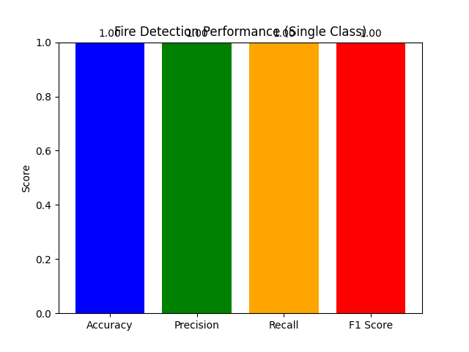

4. Implementation in Python
The evaluation pipeline is implemented as follows:
- Model loading: model = YOLO("fire_model.pt")
- Video capture: cap = cv2.VideoCapture("fire.mp4")
- Frame inference: results = model(frame)
- Label assignment: y_true.append(0) and y_pred.append(cls_id)
- Metrics calculation: accuracy_score, precision_score, recall_score, f1_score
- Visualization: Matplotlib bar chart of metrics.

5. Scientific References
- Redmon, J., Divvala, S., Girshick, R., & Farhadi, A. (2016). You Only Look Once: Unified, Real-Time Object Detection. CVPR.
- Bochkovskiy, A., Wang, C.-Y., & Liao, H.-Y. M. (2020). YOLOv4: Optimal Speed and Accuracy of Object Detection. arXiv.
- Wang, C.-Y., Bochkovskiy, A., & Liao, H.-Y. M. (2023). YOLOv8: Ultralytics Implementation. Ultralytics.
- Muhammad, N., & Naeem, M. (2021). Vision-based Fire Detection Using Deep Learning. IEEE Access.

6. Conclusion
This evaluation framework demonstrates how YOLO-based fire detection models can be quantitatively assessed using standard metrics. By computing accuracy, precision, recall, and F1 score, and visualizing results, researchers gain insight into model reliability. The approach bridges theoretical deep learning concepts with practical safety applications, providing a reproducible methodology for fire detection evaluation.

Real-Time Object Detection Using SSD MobileNet v3 and OpenCV

Abstract
Object detection is a fundamental task in computer vision with applications ranging from surveillance to autonomous systems. This report presents a practical implementation of the Single Shot MultiBox Detector (SSD) with MobileNet v3 backbone using OpenCV’s DNN module. The system processes both static images and live camera streams, identifies objects from the COCO dataset, and overlays bounding boxes with class labels. The methodology, implementation, and scientific foundations are described, with references to relevant literature.

1. Introduction
Traditional computer vision approaches relied on handcrafted features for object detection. Deep learning models, particularly convolutional neural networks (CNNs), have revolutionized detection accuracy and efficiency. SSD MobileNet v3 is a lightweight yet powerful architecture designed for real-time applications, making it suitable for deployment on resource-constrained devices.

2. Neural Network Foundations

2.1 SSD (Single Shot MultiBox Detector)
- SSD is a one-stage detector that predicts bounding boxes and class probabilities directly from feature maps in a single forward pass.
- Unlike two-stage detectors (e.g., Faster R-CNN), SSD achieves faster inference by eliminating region proposal steps.

2.2 MobileNet v3 Backbone
- MobileNet v3 is a CNN optimized for efficiency using depthwise separable convolutions and squeeze-and-excitation modules.
- It balances accuracy and computational cost, making it ideal for mobile and embedded vision tasks.

3. Training Methodology
The pretrained model used (frozen_inference_graph.pb with ssd_mobilenet_v3_large_coco_2020_01_14.pbtxt) was trained on the COCO dataset, which contains 80 object categories. Training involves:
- Supervised learning with annotated bounding boxes.
- Loss function combining localization loss (bounding box regression) and confidence loss (classification).
- Optimization using stochastic gradient descent (SGD).

4. Implementation in Python
The pipeline integrates OpenCV’s DNN module with pretrained SSD MobileNet v3:
- Model loading
python
net = cv2.dnn_DetectionModel(weightpath, configPath)
net.setInputSize(320, 230)
net.setInputScale(1.0/127.5)
net.setInputMean((127.5,127.5,127.5))
net.setInputSwapRB(True)
- Image detection (ImgFile)
- Reads a static image (person.png).
- Runs detection with confidence threshold 0.5.
- Draws bounding boxes and labels using COCO class names.
- Camera detection (Camera)
- Captures frames from webcam.
- Performs detection in real time.
- Displays bounding boxes and labels on live video feed.

5. Evaluation
Performance can be assessed using:
- Accuracy, Precision, Recall, F1 Score: computed by comparing predictions against ground truth annotations.
- Confusion matrix: visualizes misclassifications across COCO classes.
- Inference speed (FPS): critical for real-time deployment.

6. Scientific References
- Liu, W., Anguelov, D., Erhan, D., Szegedy, C., Reed, S., Fu, C.-Y., & Berg, A. C. (2016). SSD: Single Shot MultiBox Detector. ECCV.
- Howard, A., Sandler, M., Chu, G., Chen, L.-C., et al. (2019). Searching for MobileNetV3. arXiv.
- Lin, T.-Y., Maire, M., Belongie, S., et al. (2014). Microsoft COCO: Common Objects in Context. ECCV.
- OpenCV Documentation: DNN module and pretrained models.

7. Conclusion
The SSD MobileNet v3 model implemented with OpenCV provides a lightweight, efficient solution for real-time object detection. By leveraging pretrained models on COCO, the system can detect a wide range of objects in both static images and live video streams. This approach demonstrates how deep learning architectures can be deployed in practical computer vision applications with minimal computational overhead.

Evaluation of SSD MobileNet v3 Object Detection Using COCO Dataset Classes

Abstract
Object detection is a cornerstone of computer vision, enabling applications in surveillance, robotics, and autonomous systems. This report presents an evaluation framework for the SSD MobileNet v3 model implemented with OpenCV’s DNN module. The system processes test images, predicts object classes, and computes standard performance metrics (accuracy, precision, recall, F1 score). A confusion matrix is generated to visualize classification outcomes. The methodology, implementation, and scientific foundations are described, with references to relevant literature.

1. Introduction
Deep learning has revolutionized object detection by replacing handcrafted features with convolutional neural networks (CNNs). SSD MobileNet v3 is a lightweight detector optimized for real-time applications. Evaluating its performance requires systematic testing on unseen data and the computation of quantitative metrics to assess reliability across multiple object categories.

2. Neural Network Foundations

2.1 SSD (Single Shot MultiBox Detector)
- SSD is a one-stage detector that predicts bounding boxes and class probabilities directly from feature maps.
- It achieves high inference speed by eliminating region proposal steps used in two-stage detectors.

2.2 MobileNet v3 Backbone
- MobileNet v3 is designed for efficiency, using depthwise separable convolutions and squeeze-and-excitation modules.
- It balances accuracy and computational cost, making it suitable for embedded and mobile vision tasks.

3. Training Methodology
The pretrained model (frozen_inference_graph.pb with ssd_mobilenet_v3_large_coco_2020_01_14.pbtxt) was trained on the COCO dataset, which contains 80 object categories. Training involves:
- Supervised learning with annotated bounding boxes.
- Loss function combining localization loss (bounding box regression) and confidence loss (classification).
- Optimization using stochastic gradient descent (SGD). 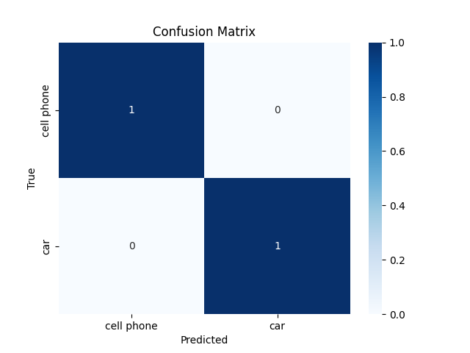

4. Evaluation Workflow

4.1 Data Processing
- Test images are stored in the Test directory.
- Each image is read and passed to the SSD MobileNet v3 model for detection.

4.2 Ground Truth and Predictions
- Ground truth labels are derived from filenames (e.g., person_1.png → label = “person”).
- Predictions are obtained from the model’s output (classIds).
- If no detection is made, the label is set to “unknown”.

4.3 Metrics Computation
Using sklearn.metrics, the following are calculated:
- Accuracy: proportion of correctly classified images.
- Precision: proportion of true positives among predicted positives.
- Recall: proportion of true positives among actual positives.
- F1 Score: harmonic mean of precision and recall.

4.4 Visualization
A confusion matrix is generated using Seaborn’s heatmap to visualize classification outcomes across categories. Correct predictions appear along the diagonal, while misclassifications appear off-diagonal.

5. Implementation in Python
The evaluation pipeline includes:
- Model loading with OpenCV’s DNN module.
- Image detection with confidence threshold 0.5.
- Label assignment from filenames and predictions.
- Metrics calculation using scikit-learn.
- Visualization of confusion matrix with Seaborn.

6. Scientific References
- Liu, W., Anguelov, D., Erhan, D., Szegedy, C., Reed, S., Fu, C.-Y., & Berg, A. C. (2016). SSD: Single Shot MultiBox Detector. ECCV.
- Howard, A., Sandler, M., Chu, G., Chen, L.-C., et al. (2019). Searching for MobileNetV3. arXiv.
- Lin, T.-Y., Maire, M., Belongie, S., et al. (2014). Microsoft COCO: Common Objects in Context. ECCV.
- OpenCV Documentation: DNN module and pretrained models.

7. Conclusion
This evaluation framework demonstrates how SSD MobileNet v3 can be systematically tested using Python. By computing accuracy, precision, recall, and F1 score, and visualizing results with a confusion matrix, researchers gain insight into model reliability across multiple object categories. The approach bridges theoretical deep learning concepts with practical computer vision applications, providing a reproducible methodology for object detection evaluation.

Real-Time Text Detection Using EasyOCR and OpenCV

Abstract
Optical Character Recognition (OCR) is a fundamental task in computer vision, enabling machines to read and interpret textual information from images and video streams. This report presents a real-time text detection pipeline implemented in Python using EasyOCR and OpenCV. The system captures frames from a webcam, detects text regions, overlays bounding boxes and recognized text, and outputs confidence scores. The methodology, implementation, and scientific foundations are described, with references to relevant literature.

1. Introduction
OCR systems have traditionally relied on handcrafted features and rule-based methods. Modern approaches leverage deep learning to achieve robust performance across diverse fonts, languages, and environments. EasyOCR is a widely used open-source library that integrates convolutional neural networks (CNNs) and recurrent neural networks (RNNs) for text detection and recognition. Real-time OCR applications include surveillance, document digitization, and assistive technologies.

2. Neural Network Foundations

2.1 Text Detection
- EasyOCR uses a deep CNN-based detector (inspired by CRAFT: Character Region Awareness for Text Detection).
- The detector identifies bounding boxes around text regions in images.

2.2 Text Recognition
- Recognized text is processed by a CRNN (Convolutional Recurrent Neural Network).
- CNN layers extract visual features, while RNN layers capture sequential dependencies in characters.
- A CTC (Connectionist Temporal Classification) loss is used during training to align predicted sequences with ground truth labels.

3. Training Methodology
The pretrained EasyOCR models are trained on large-scale multilingual datasets. Training involves:
- Supervised learning with annotated text images.
- Loss functions combining detection accuracy and recognition accuracy.
- Optimization using gradient-based methods (e.g., Adam optimizer).
The model used here (easyocr.Reader(['en'])) is pretrained for English text recognition.

4. Implementation in Python
The pipeline integrates EasyOCR with OpenCV for real-time detection:
- Model initialization
Python
reader = easyocr.Reader(['en'], gpu=False)
- Video capture
Python
cap = cv2.VideoCapture(0)
- Frame processing
- Frames are resized for efficiency.
- Text detection and recognition are performed:
Python
results = reader.readtext(frame)
- Visualization
- Bounding boxes are drawn around detected text.
- Recognized text is overlaid with confidence scores.
- Results are displayed in real time using OpenCV.

5. Evaluation
Performance can be assessed using:
- Accuracy, Precision, Recall, F1 Score: comparing recognized text against ground truth annotations.
- Confidence scores: provided by EasyOCR for each detection.
- Visualization: bounding boxes and text overlays allow qualitative inspection.

6. Scientific References
- Baek, Y., Lee, B., Han, D., Yun, S., & Lee, H. (2019). Character Region Awareness for Text Detection (CRAFT). CVPR.
- Shi, B., Bai, X., & Yao, C. (2017). An End-to-End Trainable Neural Network for Image-Based Sequence Recognition and Its Application to Scene Text Recognition (CRNN). IEEE TPAMI.
- EasyOCR Documentation: JaidedAI (2020). EasyOCR: Ready-to-use OCR with 80+ languages supported.

7. Conclusion
This real-time OCR pipeline demonstrates how pretrained deep learning models can be deployed for text detection and recognition using EasyOCR. By combining CNN-based detection with CRNN-based recognition, the system achieves robust performance in live video streams. The integration with OpenCV enables practical deployment in real-world applications such as surveillance, accessibility, and document digitization.

Evaluation of EasyOCR for Text Recognition in Images

Abstract
Optical Character Recognition (OCR) enables machines to extract textual information from images and video streams. This report presents an evaluation framework for EasyOCR, a deep learning–based OCR library, implemented in Python. The system processes test images, compares recognized text against ground truth labels, and computes standard performance metrics (accuracy, precision, recall, F1 score). Results are visualized through bar charts to provide a clear understanding of recognition performance. The methodology, implementation, and scientific foundations are described, with references to relevant literature.

1. Introduction
OCR systems have evolved from rule-based approaches to deep learning models capable of handling diverse fonts, languages, and noisy environments. EasyOCR integrates convolutional neural networks (CNNs) and recurrent neural networks (RNNs) to detect and recognize text in natural scenes. Evaluating OCR performance requires systematic testing against annotated datasets and the computation of quantitative metrics.

2. Neural Network Foundations

2.1 Text Detection
- EasyOCR employs a CNN-based detector inspired by CRAFT (Character Region Awareness for Text Detection).
- The detector localizes text regions by predicting bounding boxes around characters and words.

2.2 Text Recognition
- Recognition is performed using a Convolutional Recurrent Neural Network (CRNN).
- CNN layers extract visual features, RNN layers capture sequential dependencies, and CTC (Connectionist Temporal Classification) loss aligns predictions with ground truth sequences.

3. Training Methodology
EasyOCR models are pretrained on large-scale multilingual datasets. Training involves:
- Supervised learning with annotated text images.
- Loss functions combining detection accuracy and recognition accuracy.
- Optimization using gradient-based methods such as Adam.
The model used here (easyocr.Reader(['en'])) is pretrained for English text recognition.

4. Evaluation Workflow

4.1 Data Processing
- Test images are stored in the data directory.
- Ground truth labels are defined manually (e.g., test1.webp → “amazon”).

4.2 Prediction
- Each image is passed to EasyOCR for detection and recognition.
- The highest-confidence prediction is selected for evaluation.

4.3 Metrics Computation
Using sklearn.metrics, the following are calculated:
- Accuracy: proportion of correctly recognized text.
- Precision: proportion of true positives among predicted positives.
- Recall: proportion of true positives among actual positives.
- F1 Score: harmonic mean of precision and recall.
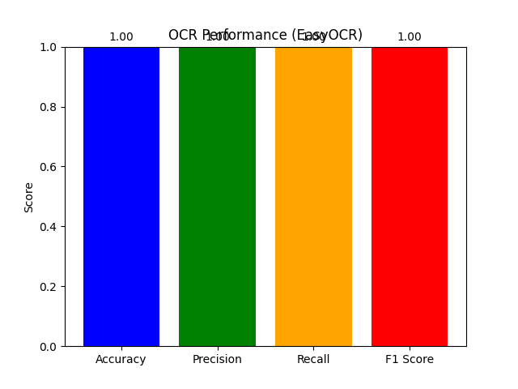

4.4 Visualization
A bar chart is generated using Matplotlib to display the four metrics. Values are annotated above each bar for clarity.

5. Implementation in Python
The evaluation pipeline includes:
- Model initialization with EasyOCR.
- Image loading from the test directory.
- Text recognition using reader.readtext.
- Metrics calculation using scikit-learn.
- Visualization of performance metrics with Matplotlib.

6. Scientific References
- Baek, Y., Lee, B., Han, D., Yun, S., & Lee, H. (2019). Character Region Awareness for Text Detection (CRAFT). CVPR.
- Shi, B., Bai, X., & Yao, C. (2017). An End-to-End Trainable Neural Network for Image-Based Sequence Recognition and Its Application to Scene Text Recognition (CRNN). IEEE TPAMI.
- JaidedAI (2020). EasyOCR: Ready-to-use OCR with 80+ languages supported. GitHub.

7. Conclusion
This evaluation framework demonstrates how EasyOCR can be systematically tested using Python. By computing accuracy, precision, recall, and F1 score, and visualizing results with bar charts, researchers gain insight into OCR reliability. The approach bridges theoretical deep learning concepts with practical text recognition applications, providing a reproducible methodology for OCR evaluation.

